Victoria Medieval Association 2017

The Victoria Medieval Association was founded in 1988 with the purpose of fostering and encouraging the large and “lively community of interest in the Middle Ages among people” of the island and beyond. The association is open to all; membership is granted on request, sent by email to medi@uvic.ca or by snail mail to
The Program of Medieval Studies,
University of Victoria, Clearihue D 267,
PO Box 1700 STN CSC,
Victoria, BC V8W 2Y2.
Managed through the program of Medieval Studies at the University of Victoria, the association will sponsor events such as lectures, workshops, and a newsletter with the goal of circulating information and invitations to medieval events on the island, particularly the new Victoria Medieval Conference, to be held on the first Saturday of February.

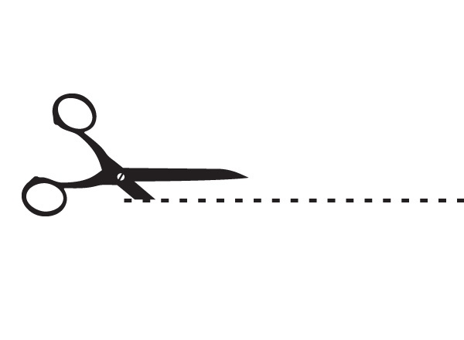
If you are interested in receiving news from the Victoria Medieval Association and/or in being a member, please fill and return the form below. Welcome!

................................................................................................................................................

Victoria Medieval Association Membership form
To be returned to Medieval Studies,
Clearihue D 267, University of Victoria

Name:_______________________________
First name:__________________________

Contact
Email:
Telephone:
Mailing address: ______________________
__________________________________________
__________________________________________
__________________________________________
__________________________________________
__________________________________________

If applicable, Twitter account:

Preferred format for communication: Email ☐ Letter ☐
Do you wish to receive emails about medieval news ? Yes ☐ No ☐

